*README*

*High Volume Precipitation Spectrometer-3 (HVPS) Dataset*

*GOAmazon*

*Phase 1: Feb. 22 – Mar. 23, 2014*

*Phase2: Sep. 6 – Oct. 4, 2014*

*Contact:*

*Jennifer Comstock, ARM Aerial Facility, PNNL*

[jennifer.comstock@pnnl.gov](mailto:jennifer.comstock@pnnl.gov)

# Data Source

These data were collected onboard the Gulfstream-1 operated by Battelle for the U.S. Department of Energy DOE during the Atmospheric Radiation Measurement (ARM) programs GOAmazon field campaign as part of a joint ARM Aerial Facility (AAF) and ARM Mobile Facility (AMF) deployment (Principle Investigator Scot Martin, Harvard University).

## 1.1 Location

Aircraft flights were based out of Eduardo Gomes Airport, Manaus, Amazonas, Brazil. Flight plans focused on sampling the Manaus plume and convective clouds in the vicinity of Manaus and over the ARM Mobile Facility located near Manacaparu. Flight plans included level legs that were typically below cloud base, then inside and above cloud. The HVPS-3 probe was mounted on the wing pylon located on the left hand side of the G-1.

## 1.2 Time period of collection

Flights occurred Feb. 25 – Mar. 23, 2014 and Sep. 6 – Oct. 4, 2014.

## 1.3 Instrument description and data processing

The HVPS probe is manufactured by SPEC Inc. (<http://www.specinc.com>) and measures cloud particle size distribution from 75.0 to 9075 μm using the same optical imaging technique as the SPEC 2DS probe. The laser beam and 128-photodiode array is designed to measure shadowgraph images with 150 μm pixel resolution (note the 2DS uses 10 μm pixel resolution). The maximum field of view is 1.92 cm. The sample volume is 400 L/s at 100 m/s. Vendor supplied software is used to process the images and retrieve the particle size distributions. A detailed description of the HVPS probe specifications is available in the instrument installation and data processing manuals (<http://www.specinc.com>). The option used to process the data was “Archive_multi_ice_ascii” and the “M1” output is archived. See data processing manual for details.

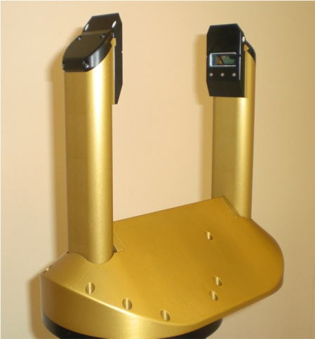

Figure 1: HVPS probe.

# 2.0 File Format

The file format follows the ICARTT format (http://www-air.larc.nasa.gov/missions/etc/ESDS-RFC-019-v1.1_0.pdf ), which is a standardized file format designed for aerial platforms by the Inter-Agency Working Group For Airborne Data And Telemetry Systems (IWGADTS: http://www.eol.ucar.edu/iwgadts/index.html). All data are 1 sec temporal resolution.

## 2.1 File naming convention

The file naming convention also follows the ICARTT standard:

HVPS_G1_YYYYMMDDHHMMSS_R2_GoAmazon001s.ict

Table 1: Explanation of file naming convention for HVPS data.

|  |  |
| --- | --- |
| Label | Notes |
| HVPS | Instrument Name |
| G1 | Aircraft Platform |
| YYYYMMDD | YearMonthDay |
| HHMMSS | HourMinuteSecond |
| R2 | Revision |
| GoAmazon | Field Campaign Name |
| 001s | Denotes 1 Hz data |

## 2.2 Data description

Table 2: Description of column data provided in HVPS data files. All bin sizes are listed in microns. See data file for complete list of bin sizes.

|  |  |  |  |
| --- | --- | --- | --- |
| Column | Column Name | Units | Description |
| 1 | Time | seconds | Seconds since midnight |
| 2 | Conc(#/L) | (#/L/μm) | Total number concentration |
| 3 | C:75-225 | (#/L/ μm) | Number concentration in Bin 1 75-225 μm |
| 4 | C:225-375 | (#/L/ μm) | Number concentration in Bin 2 225-375 μm |
| 5 | C:375-525 | (#/L/ μm) | Number concentration in Bin 3 375-525 μm |
| 6 | … |  |  |
| 61 | C:8325-9075 | (#/L/ μm) | Number conc. in Bin 61 8325-9075 μm |

# Note that due to instrument problem, we do not have HVPS data for 20140222a flight.