How to use soundings from global model data

Accurate radiosonde data from model analyses (and forecasted data),
are much better than data calculated with standard atmospheres,for every location on earth on a 0.5° grid from the web site
http://rucsoundings.noaa.gov/

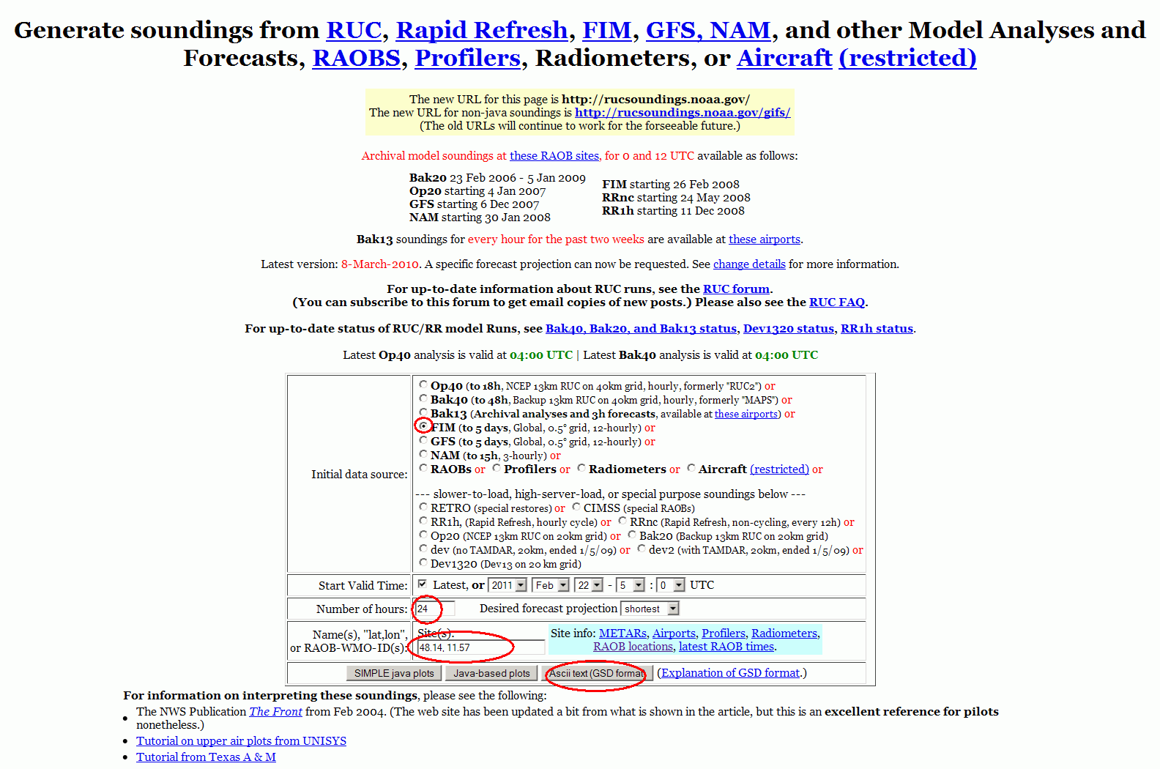

1. Load the website
2. Select, FIM, 24 or 12 or 8 for Number of Hours, put your lat and long (like: 34.7, 33.07)
3. Click on the Ascii Format (GSD)

At the new page that will appear use your mouse to select the data that you want like below
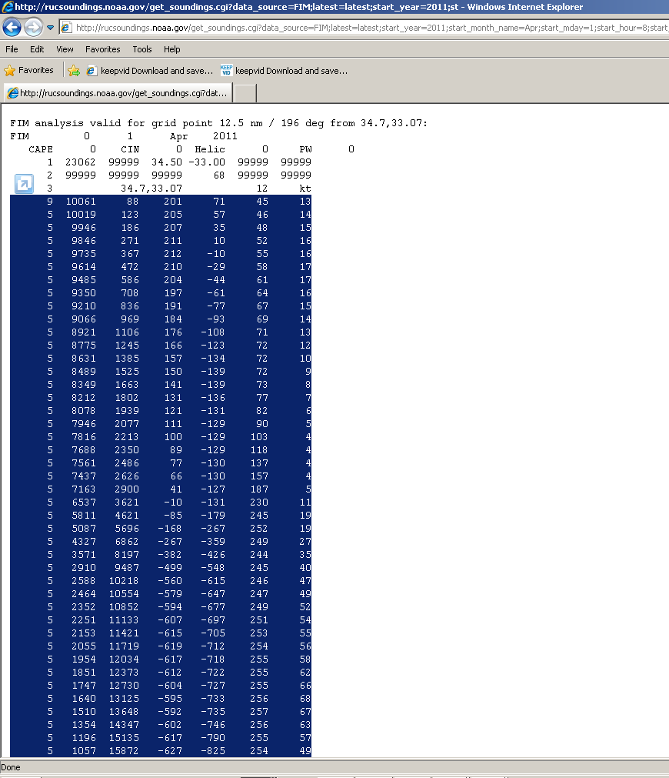

Copy the data (Select and righ click to copy)
Open a text editor and past the data. Save the file with a name that you want (like Road_Data.txt).
The columns that we are interesting for are the column 2 (pressure in tenths of milibars), column 3 (altitude in meters) and the column 2 (temperature in tenths of Celsius).

We have build a tool to convert the Road_Data.txt file to another formatted ascii file suitable to be read by Raymetrics software.
Raymetrics software needs to read an ascii file with three columns separated by tab.
First Column: Altitude in meters
Second Column: Temperature in K
Third Column: Pressure in hPa.

Locate the Rm_Utils.llb and run the ROAD_GSD_to_Ascii_Format.vi
Select the file that you want to convert eg. Road_Data.txt.
The software will ask to save the formatted data to another file. Then give another filename for the formatted file eq. Road_Data_formated.txt (if you like you can overwrite the original one).

Now at the analysis interface you can click on the Config button

Then click on the Use Radiosonde Check box and then load the formatted ascii file by clicking on the folders icon. Then Click ok.

